1. Something related to **ngStyle** is **ngClass**.
2. **ngStyle**: Allows to dynamically add css styles.
3. **ngClass**: Allows to dynamically add/remove css class. 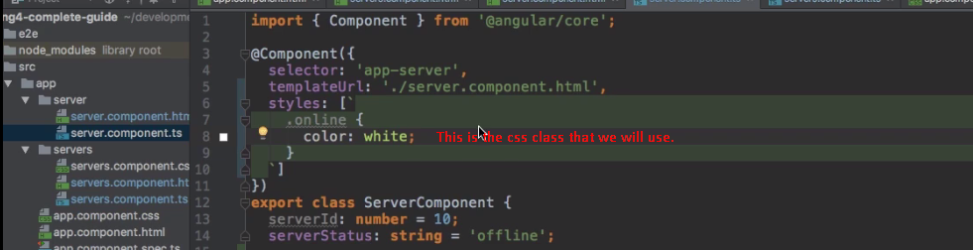
4. 